Nishant Jha’s Report on:

Explore weather trends

# Data acquisition

**SQL** Queries were used to acquire the data required for this study project.

## **SQL Query:**

### To find the local city:

#### SELECT * FROM city_list

#### WHERE city = ‘Bangalore’ AND country = ‘India’;

### With the local city confirmed, it’s time to acquire the global & local temperature data for the corresponding years.

#### SELECT g.year, g.avg_temp globaltemp,

#### c.avg_temp localtemp

#### FROM global_data g, city_data c

#### WHERE c.city = ‘Bangalore’

#### AND c.year = g.year;

The database is downloaded in .csv format, and later imported in Microsoft Excel and saved in .xlsx format for further studies. Here are the first 10 rows:

### 

# Moving average calculation

Moving average, basically the average over a periodic time (in this case 10 years), was calculated for both, the global & local data.

Here the first three MA can be seen for both the global & local data.

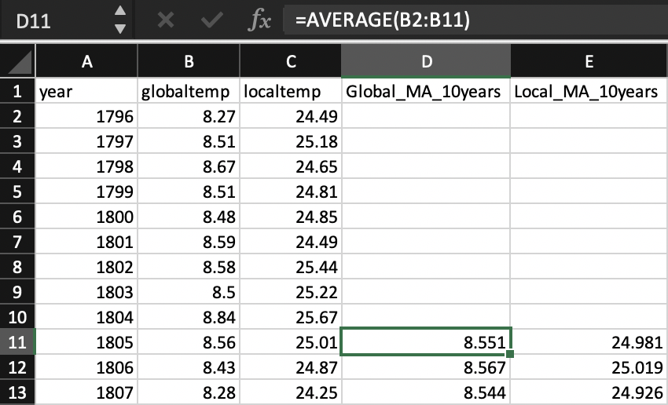

Here’s of the last 10 rows.

# 

# Data visualization

Line charts are used for data visualization. Here, Microsoft Excel Line charts were used.

First line chart:

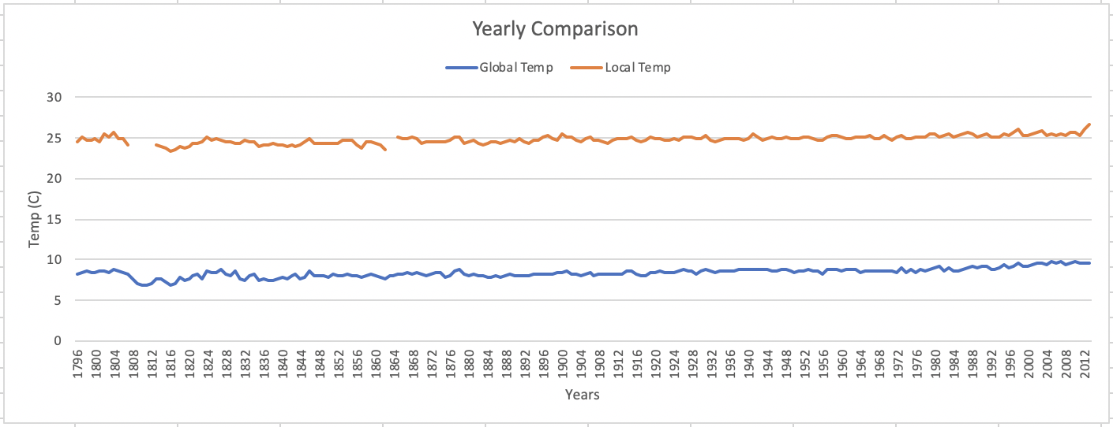

Due to larger disturbances, observations can’t be made easily. Hence, the moving average comes to the rescue. It also helps in filling the gaps for missing data.

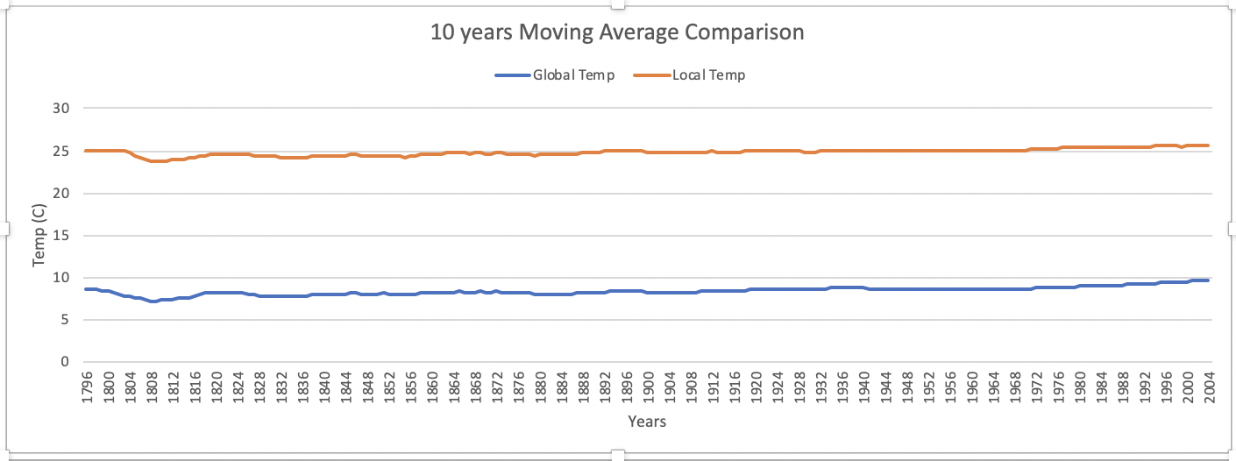

# observations

Here are my observations:

* Local average temperature is maintained around 25 degree C whereas global average temperature is around 8 degree C & hence local average temperature is greater than global average temperature.
* The difference in average temperature, as it can be seen in the MA plot, is almost consistent throughout the years but as it can be seen in the period of 2000-2004 years, the temperature increase rate for global average temperature is more slightly than that of local temperature.
* Here only one on local city was taken into consideration, considering the fact that several local cities have an increasing temperature rate, this is directly affecting the global yearly average temperature which is also getting increased as stated in the above point.
* There was a drop-in temperature that can be seen in the period of 1800 – 1820 years.
* Overall, the cities are getting hotter year by year directly affecting the global average temperature.
* Here are the correlation coefficients:
  + Global: 0.76526748
  + Local: 0.70740853